Your physical exercise self-care vision
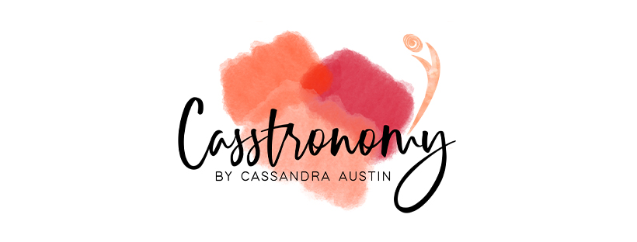
Create a Vision for success, make it sexy for you!
You are ready to live your best life “Hell Yes”.

Physical exercise
A bodily activity that enhances you or maintains physical and overall health and well-being. Benefits vary including
· Strengthening muscles
· Cardiovascular system
· Honing athletic skills
· Weight loss or maintenance and for enjoyment
Frequent and regular physical exercise boosts the immune system, and helps prevent the diseases bought on by modern affluence" such as heart disease, cardiovascular disease and obesity It also improves mental health, helps prevent depression, promote and maintain positive self-esteem, it can even assist an individual's sex appeal or body image, which again is also linked with higher levels of self-esteem. Child hood obesity is a growing global concern and physical exercise can help decrease the effects of childhood obesity in developed countries.
Here is a helpful link with more information
https://www.health.gov.au/health-topics/physical-activity-and-exercise/about-physical-activity-and-exercise

If this area was better, what would you be able to do that you aren’t doing now?

How would you feel about yourself?

How would that affect people around you?

What is stopping you from getting there?

How long has this been going on?

What have you done to try to change?

What is the cost of not changing?

How do you feel about that?

If nothing changes what impact will that have on you?

What do you want to do about this?

Do you have a good mental image of what it would be like?
Now write it in clear simple language

My Vision to be the best I can be is to
1.

2.

3.

4.

5.

The reasons I want it are
1.

2.
3.

4.

5.

Some of the Obstacles that could get in the way
1.

2.

3.

4.

5.

My ideas of some strategies include
1.

2.
3.

4.

5.

My strengths of what I have going for me include?
1.

2.

3.

4.

5.

What achievements of the past required effort?
1.

2.

3.

4.

5.
What did it take to succeed at those endeavours?
1.
2.
3.
4.
5.
How could I use those strengths to make the change I would like to be the best I can be?
________________________________________________________________________________________________________________________________________________________________________________________________________________________________________________________________________________________________________________________________________________________________________________________________________________________________________________________________

This is your plan
Make it sexy for you
Have it pop up as a reminder daily for yourself however you will remember it best
Revisit and refresh when necessary

