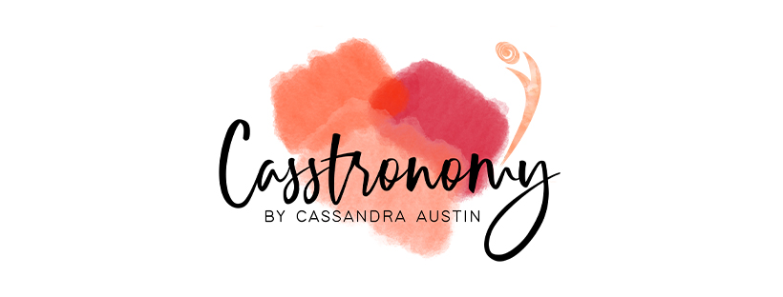

Golden milk Ice cream, chocolate sauce & blueberries
Serves 8

Gluten Free, Dairy Free, Vegetarian

Difficulty Easy

Ingredients

420 ml coconut milk
210 ml coconut cream
1 cup salted, roasted cashew nuts
½ cup maple syrup
2 tsp turmeric
1 tsp cinnamon
1 tsp ground ginger
2 tbsp toasted coconut

Method
Soak cashew nuts in water overnight
Blend all ingredients
Coat a high sided pan with coconut oil sprayed greaseproof paper
Freeze

Tip

Remove from the freezer before required to serve as it sets harder than normal dairy ice-cream

Dairy free chocolate sauce

Organic Cacao powder
Cold pressed coconut oil
Maple syrup
Mix ingredients to form a light sauce consistency and serve at a temperature the coconut oil is liquid, it will set like magic ice when poured over the frozen golden milk ice-cream.

Fresh blueberries

200gm fresh blueberries

Method

Scoop Icecream using hot water and a scoop and have ready in your freezer before hand to make serving easy!

Top with chcoclate sauce and fresh blueberries

